 **Static Web Design using HTML**

**Lab02**

**Fall 2024**

Submitted by: **Mohsin Sajjad**

Registration No: **22pwsce2149**

Class Section: **A**

“On my honor, as student of University of Engineering and Technology, I have neither given nor received unauthorized assistance on this academic work.”



Student Signature: ______________

Submitted to:

**Engr. Summeya Salahudin**

Month Day, Year (02 23, 2025)

Department of Computer Systems Engineering

University of Engineering and Technology, Peshawar

**Objectives of The Lab:**

This lab aims at the understanding of:

1. The basic syntax and structure of HTML.
2. Identify the different types of headings and the appropriate usage for each.
3. Understand how to create and use rules to style HTML elements.
4. Learn how to use comments in HTML to provide additional information and context for
5. the code.
6. Understand how to structure paragraphs in HTML and use appropriate formatting tags.
7. Understand how to use HTML styles to change the appearance of text and other
8. elements.
9. Learn how to create and format tables in HTML.
10. Learn how to create and format lists in HTML.
11. Understand how to create and use forms to collect user input.

**Example 1:**

<html>

<head>

<title> My First Webpage </title>

</head>

<body>

<!--This comment will not be displayed-->

<h1> My First Heading </h1>

<p> My First Paragraph </p>

</body>

</html>

**Output:**

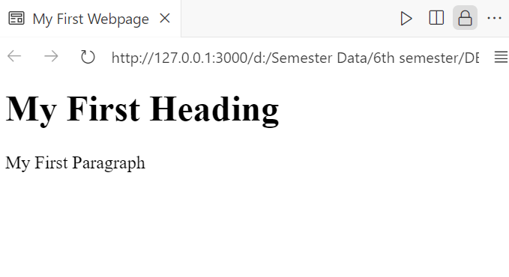

### Conclusion:

1. **Title:** The webpage is named "My First Webpage."
2. **Hidden Note:** There’s a comment in the code, but it won’t show on the page.
3. **Heading & Text:** It shows a big title and a short paragraph.
4. **Basic Webpage:** It’s a simple webpage to learn how HTML works.

**Example #02:**

<html>

<head>

<title> HTML document with Background Attribute </title>

</head>

<body background="images/image1.jpeg">

<h1> This is heading 1. </h1>

<p> This is a paragraph. </p>

</body>

</html>

**Output:**

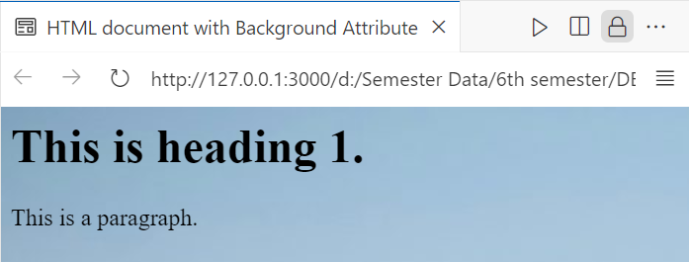

**Conclusion:**

1. **Title:** The webpage is named "HTML document with Background Attribute."
2. **Background Image:** It sets an image (image1.jpeg) as the background.
3. **Content:** It displays a heading and a paragraph.
4. **Purpose:** Shows how to add a background image to a webpage.

**Example 03:**<html>

<head>

<title> Text Formatting in HTML </title>

</head>

<body>

<p> <b> This text is bold. </b>

<p> <i> This text is italic. </i>

<p> <big> This text is big. </big>

<p> <small> This text is small. </small>

<p> This is <sub> subscript </sub> and <sup> superscript </sup> text.

</body>

</html>

**Output:**

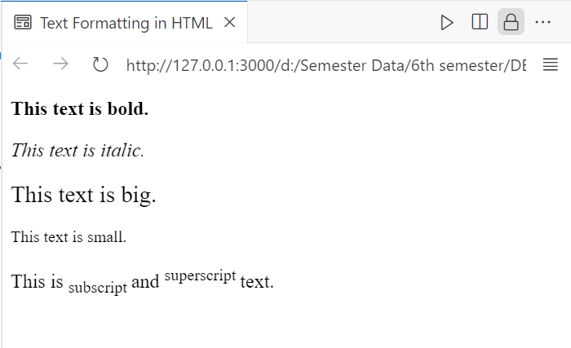

**Conclusion:**

1. **HTML Structure** – The document follows the basic HTML structure with <html>, <head>, and <body> tags.
2. **Title Tag** – The <title> tag sets the title as *"Text Formatting in HTML."*
3. **Bold and Italic Text** – The <b> tag makes text bold, and the <i> tag makes text italic.
4. **Text Size Formatting** – The <big> tag enlarges text, while <small> reduces its size.
5. **Subscript and Superscript** – The <sub> tag creates subscript text, and <sup> creates superscript text.
6. **Missing Closing Tags** – <p> tags should be properly closed (</p>) to follow correct HTML syntax.
7. **Demonstrates Formatting** – The page effectively showcases various text formatting options in HTML.

**Example 04:**

<html>

<head>

<title> Using Preformatted Text in HTML </title>

</head>

<body>

<html>

<head>

<title> Using Preformatted Text in HTML </title>

</head>

<body>

<pre><code>

a = 2;

for i = 1:10

i = i+a

end

</code></pre>

</body>

</html>

</body>

</html>

**Output:**

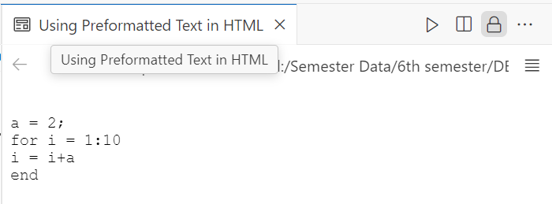

**Conclusion:**

1. **HTML Structure Issue** – The document has duplicate <html>, <head>, and <body> tags, which should be removed for proper formatting.
2. **Title Tag** – The <title> tag sets the page title as *"Using Preformatted Text in HTML."*
3. **Preformatted Text** – The <pre> tag preserves whitespace and line breaks, displaying text exactly as written.
4. **Code Formatting** – The <code> tag is used inside <pre> to represent programming code.
5. **Syntax Example** – The provided code snippet appears to resemble MATLAB or a similar programming language.
6. **Correction Needed** – The extra <html>, <head>, and <body> tags should be removed to follow proper HTML syntax.
7. **Effective Demonstration** – The page successfully demonstrates how to display code using HTML formatting tags.

**Example 05:**<html>

<head>

<title> Use of Abbreviations and Acronyms </title>

</head>

<body>

<!--The title attribute is used to show the spelled-out

version when holding the mouse pointer over the acronym

or abbreviation.-->

<abbr title="University of Engineering & Technology"> UET </abbr> <br>

<acronym title="Dept. of Computer Systems Eng."> DCSE </acronym>

</body>

</html>

**Output:**

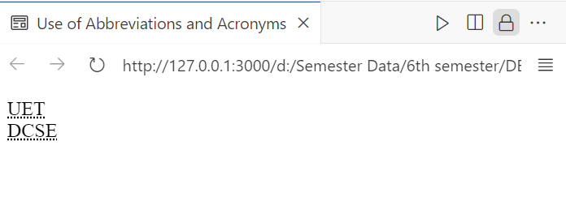

**Conclusion:**

1. **HTML Structure** – The document follows a proper HTML structure with <html>, <head>, and <body> tags.
2. **Title Tag** – The <title> tag sets the page title as *"Use of Abbreviations and Acronyms."*
3. **Abbreviations** – The <abbr> tag is used for abbreviations, providing a tooltip with the full form when hovered.
4. **Acronyms (Deprecated)** – The <acronym> tag is used for acronyms, but it is deprecated in HTML5 and should be replaced with <abbr>.
5. **Line Break** – The <br> tag ensures that "DCSE" appears on a new line for better readability.
6. **Effective Demonstration** – The page correctly showcases how to use the title attribute to display expanded text.
7. **Improvement Suggestion** – Replace <acronym> with <abbr> for modern HTML compliance.

**Example 06:**

<html>

 <head>

<title> Use of Styles </title>

 </head>

 <body style="background-color:Gray;">

 <h1> Styles in HTML </h1>

 <p style="font-family:Calisto MT; color:blue">

 This text is in Calisto MT and blue. </p>

 <p style="font-family:arial; color:white">

 This text is in Arial and white. </p>

<p style="font-size:30px">

This text is 30 pixels high. </p>

<p style="font-family:arial; color:brown; font-size:20px">

A paragraph </p>

<h1 style="text-align:center"> This is heading. </h1>

</body>

</html>

**Output:**

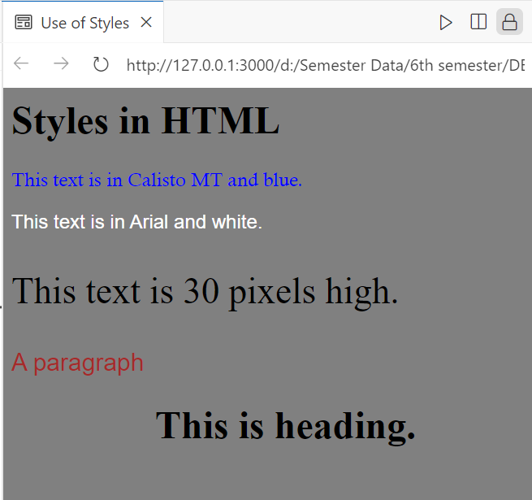

**Conclusion:**

This HTML page demonstrates the use of **inline styles** to change the background color, text color, font family, font size, and text alignment. It sets a **gray background**, applies different **fonts and colors** to paragraphs, adjusts **text size**, and centers a **heading**.

**Example 07:**

<html>

<head>

    <title> Use of References </title>

</head>

<body>

    <p>

        <a href="Ex03.html"> <!-- anchor example -->

        This text </a> is a link to a page on this Website.

    </p>

    <p>

        <a href="http://www.nwfpuet.edu.pk/"> <!-- hyperlink example -->

        This text </a> is a link to a page on the World Wide Web.

    </p>

</body>

</html>

**Output:**

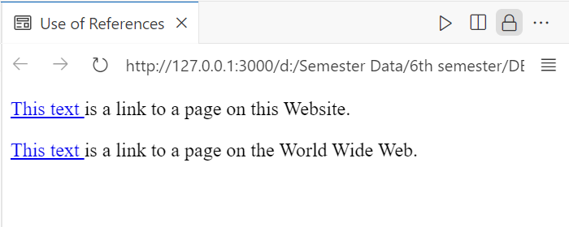

**Conclusion:**

This HTML page demonstrates the **use of hyperlinks** with the <a> (anchor) tag:

1. **Internal Link** – Links to another page (Ex03.html) within the same website.
2. **External Link** – Links to an external website (http://www.nwfpuet.edu.pk/).
3. **Anchor Tags** – The <a> tag is used to create clickable text that redirects users.
4. **Comments** – Comments (<!-- -->) describe the purpose of each link.

This makes navigation between web pages easier.

**Example 08:**<html>

<head>

<title> Opening Link in a New Window </title>

</head>

<body>

<a href="Ex02.html" target="_blank">

This text </a> is a link to a page on this Website.

</body>

</html>

**Output:**

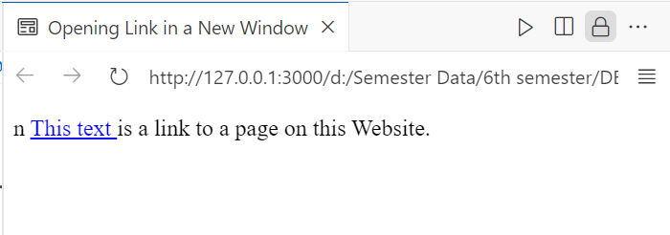

**Conclusion:**

This HTML page demonstrates how to **open a link in a new window/tab** using the <a> tag:

1. **Hyperlink** – The <a> tag links to Ex02.html.
2. **target="_blank"** – This attribute ensures the link opens in a **new tab or window** instead of the same page.

It helps users navigate without leaving the current page.

**Example 09:**

<html>

<head>

    <title> Table Creation in HTML </title>

</head>

<body style="background-color: Gray;">

    <h4>Table Creation in HTML</h4>

    <table border="5" cellpadding="10" cellspacing="10" bgcolor="grey">

        <caption>First Table in HTML</caption>

        <tr>

            <td>100</td>

            <td>200</td>

            <td>300</td>

        </tr>

        <tr>

            <td>400</td>

            <td>500</td>

            <td>600</td>

        </tr>

    </table>

</body>

</html>

**Output:**

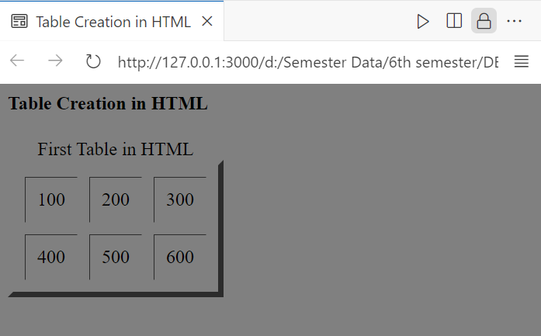

**Conclusion:**

This HTML page demonstrates **table creation** with the following features:

1. **Background Color** – The page background is set to **gray**.
2. **Table Attributes** – The table has a **border (5px), cell padding (10px), and cell spacing (10px)**.
3. **Caption** – The table includes a **title ("First Table in HTML")** above it.
4. **Rows and Columns** – The table contains **two rows and three columns** with numeric values.

It effectively showcases how to create and style a table in HTML.

**Example 10:**<html>

<head>

    <title>Table with Different Heading Styles</title>

</head>

<body style="background-color: Gray;">

    <h4>Horizontal headers:</h4>

    <table border="1">

        <tr>

            <th>Heading</th>

            <th>Another Heading</th>

        </tr>

        <tr>

            <td>row 1, cell 1</td>

            <td>row 1, cell 2</td>

        </tr>

        <tr>

            <td>row 2, cell 1</td>

            <td>row 2, cell 2</td>

        </tr>

    </table>

    <h4>Vertical headers:</h4>

    <table border="1">

        <tr>

            <th>First Name:</th>

            <td>Bill Gates</td>

        </tr>

        <tr>

            <th>Telephone:</th>

            <td>555 777 1854</td>

        </tr>

        <tr>

            <th>Telephone:</th>

            <td>555 777 1855</td>

        </tr>

        <tr>

            <th>Telephone:</th>

            <td>&nbsp;</td>

        </tr>

    </table>

</body>

</html>

**Output:**

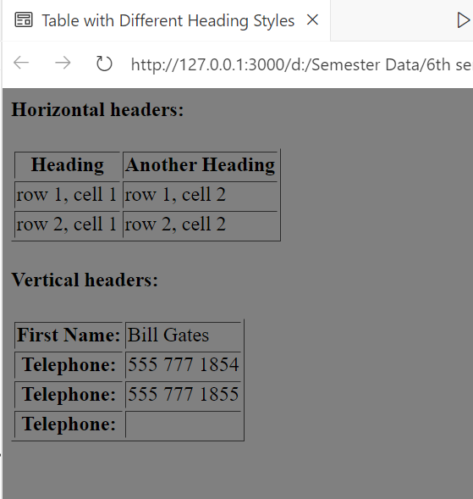

### Conclusion:

This HTML page demonstrates **different table heading styles** with the following features:

1. **Background Color** – The page background is set to **gray**.
2. **Horizontal Headers** – The first table has **column headers** (<th>) at the top.
3. **Vertical Headers** – The second table has **row headers** (<th>) on the left.
4. **Empty Cell Handling** – The &nbsp; (non-breaking space) is used to leave an empty cell.

It effectively shows how to format tables with both **horizontal and vertical headers** in HTML.

**Example 11:**<!DOCTYPE html>

<html>

<head>

    <title>Usage of Frames Attribute with HTML Table</title>

</head>

<body style="background-color:Gray;">

    <h4>With frame="border":</h4>

    <table frame="border">

        <tr>

            <td>First</td>

            <td>Row</td>

        </tr>

        <tr>

            <td>Second</td>

            <td>Row</td>

        </tr>

    </table>

    <h4>With frame="box":</h4>

    <table frame="box">

        <tr>

            <td>First</td>

            <td>Row</td>

        </tr>

        <tr>

            <td>Second</td>

            <td>Row</td>

        </tr>

    </table>

    <h4>With frame="void":</h4>

    <table frame="void">

        <tr>

            <td>First</td>

            <td>Row</td>

        </tr>

        <tr>

            <td>Second</td>

            <td>Row</td>

        </tr>

    </table>

    <h4>With frame="above":</h4>

    <table frame="above">

        <tr>

            <td>First</td>

            <td>Row</td>

        </tr>

        <tr>

            <td>Second</td>

            <td>Row</td>

        </tr>

    </table>

    <h4>With frame="below":</h4>

    <table frame="below">

        <tr>

            <td>First</td>

            <td>Row</td>

        </tr>

        <tr>

            <td>Second</td>

            <td>Row</td>

        </tr>

    </table>

    <h4>With frame="hsides":</h4>

    <table frame="hsides">

        <tr>

            <td>First</td>

            <td>Row</td>

        </tr>

        <tr>

            <td>Second</td>

            <td>Row</td>

        </tr>

    </table>

    <h4>With frame="vsides":</h4>

    <table frame="vsides">

        <tr>

            <td>First</td>

            <td>Row</td>

        </tr>

        <tr>

            <td>Second</td>

            <td>Row</td>

        </tr>

    </table>

    <h4>With frame="lhs":</h4>

    <table frame="lhs">

        <tr>

            <td>First</td>

            <td>Row</td>

        </tr>

        <tr>

            <td>Second</td>

            <td>Row</td>

        </tr>

    </table>

    <h4>With frame="rhs":</h4>

    <table frame="rhs">

        <tr>

            <td>First</td>

            <td>Row</td>

        </tr>

        <tr>

            <td>Second</td>

            <td>Row</td>

        </tr>

    </table>

</body>

</html>

**Output:**

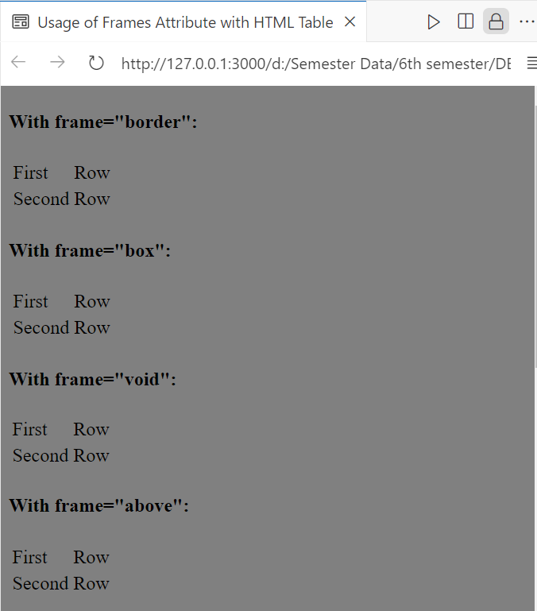

**Conclusion:**

This HTML page demonstrates the **usage of the frame attribute** in tables:

1. **Background Color** – The page background is set to **gray**.
2. **Different Frame Styles** – Various frame types (border, box, void, above, below, hsides, vsides, lhs, rhs) are applied to tables.
3. **Frame Effects** –
   * "border" surrounds the table with a full border.
   * "box" encloses the table in a box.
   * "void" removes the border.
   * "above" and "below" show top or bottom borders only.
   * "hsides" and "vsides" add horizontal or vertical borders.
   * "lhs" and "rhs" show borders on the left or right sides.

**Example 12:** <html>

 <head>

 <title> Use of Unordered List </title>

 </head>

 <body>

 <h4>An Unordered List:</h4>

 <ul type="disc">

 <li>Coffee</li>

  <li>Tea</li> <li>Milk</li>

 </ul>

 <ul type="circle">

 <li>Coffee</li>

 <li>Tea</li>

 <li>Milk</li>

 </ul>

 <ul type="square">

 <li>Coffee</li>

 <li>Tea</li>

 <li>Milk</li>

 </ul>

 </body>

 </html>

**Output:**

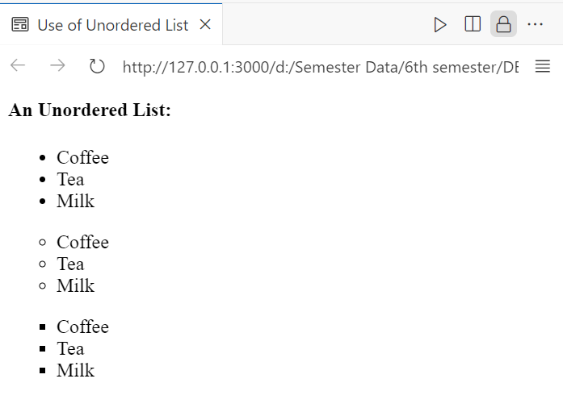

**Conclusion:**

This HTML page demonstrates the **use of unordered lists (<ul>)** with different bullet styles:

1. **type="disc"** – Uses **solid round bullets** (default).
2. **type="circle"** – Uses **hollow circle bullets**.
3. **type="square"** – Uses **square bullets**.

Each list contains **three items**: Coffee, Tea, and Milk.

**Example 13:**

<html>

<head>

<title> Use of Ordered List </title>

</head>

<body>

<h4>Letters List:</h4>

<ol type="A">

<li>Coffee</li>

<li>Tea</li>

 <li>Milk</li>

 </ol>

 <h4>Lowercase Letter List:</h4>

 <ol type="a">

 <li>Coffee</li>

 <li>Tea</li>

 <li>Milk</li>

 </ol>

 <h4>Roman Number List:</h4>

 <ol type="I">

 <li>Coffee</li>

 <li>Tea</li>

 <li>Milk</li>

 </ol>

 <h4>Lowercase Roman Number List:</h4>

 <ol type="i">

 <li>Coffee</li>

 <li>Tea</li>

 <li>Milk</li>

 </ol>

 </body>

 </html>

**Output:  
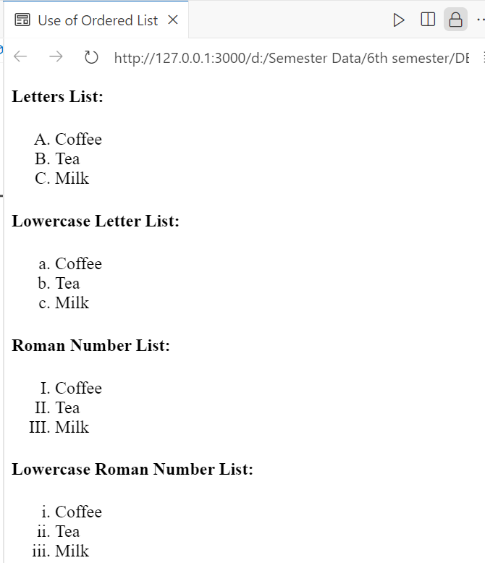**

### Conclusion: This HTML page demonstrates the **use of ordered lists (**<ol>**)** with different numbering styles:

1. **type="A"** – Uses **uppercase letters** (A, B, C...).
2. **type="a"** – Uses **lowercase letters** (a, b, c...).
3. **type="I"** – Uses **uppercase Roman numerals** (I, II, III...).
4. **type="i"** – Uses **lowercase Roman numerals** (i, ii, iii...).

Each list contains **three items**: Coffee, Tea, and Milk.

**Example 14:**<html>

<head>

<title> Use of Definition List </title>

</head>

<body>

<h4>A Definition List:</h4>

<dl>

<dt>Coffee</dt>

<dd>Black Hot Drink</dd>

 <dt>Milk</dt>

 <dd>White Cold Drink</dt>

 </dl>

 </body>

 </html>

**Output:**

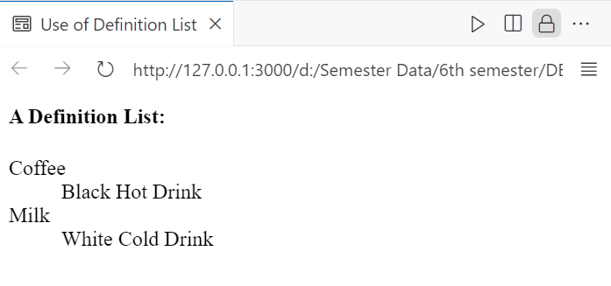

**Conclusion:**

This HTML page demonstrates the **use of a Definition List (<dl>)**, which consists of:

1. **<dt> (Definition Term)** – Represents the term being defined (e.g., Coffee, Milk).
2. **<dd> (Definition Description)** – Provides the definition or explanation of the term (e.g., Black Hot Drink, White Cold Drink).

**Example 15:**

<html>

<head>

<title> Form Creation in HTML </title>

</head>

<body>

<form action="">

First Name:

<input type="text" name="first name" />

 <br/>

 Last Name:

 <input type="text" name="last name" />

 <br/> <br/>

 I've a bike:

 <input type="checkbox" name="vehicle" value="bike" checked/> <br/>

 I've a car:

 <input type="checkbox" name="vehicle" value="car" />

 <br/> <br/>

 Male:

 <input type="radio" name="sex" value="male" checked/> <br/>

 Female:

 <input type="radio" name="sex" value="female" />

 <br/> <br/>

 <input type="button" value="Hello World!" />

 <br/> <br/>

 <select name="cars">

 <option value="mehran">Mehran</option>

 <option value="liana">Liana </option>

 <option value="gimini">Gimini</option>

 </select>

 <br/><br/>

 </form>

 </body>

 </html>

**Output:**

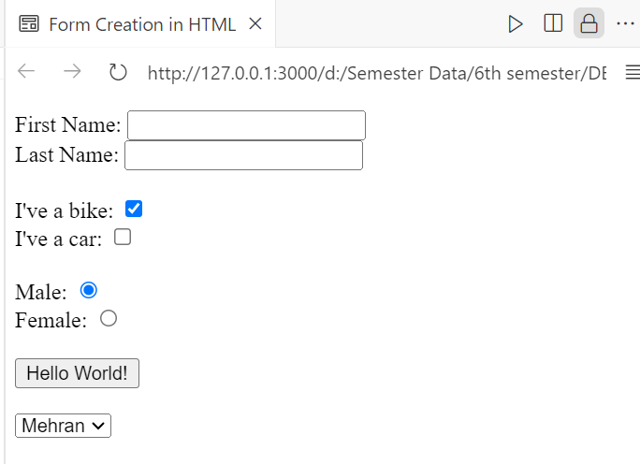

### Conclusion: This HTML page demonstrates the **creation of a form** with various input fields:

1. **Text Inputs** – Fields for **First Name** and **Last Name**.
2. **Checkboxes** – Options for selecting **Bike** or **Car** (Bike is pre-selected).
3. **Radio Buttons** – Gender selection (**Male** is pre-selected).
4. **Button** – Displays "Hello World!" but doesn’t perform any action.
5. **Dropdown (<select>)** – Allows the user to choose a car from **Mehran, Liana, or Gimini**.

**Example 16:**

<html>

<head>

<title> Use of Fieldset, Legend, and Textarea Tags </title>

</head>

<body>

<fieldset>

<legend>text area legend</legend>

<textarea rows="10" cols="30">

The cat was playing in the garden.

 </textarea>

 </fieldset>

 </body>

 </html>

**Output:  
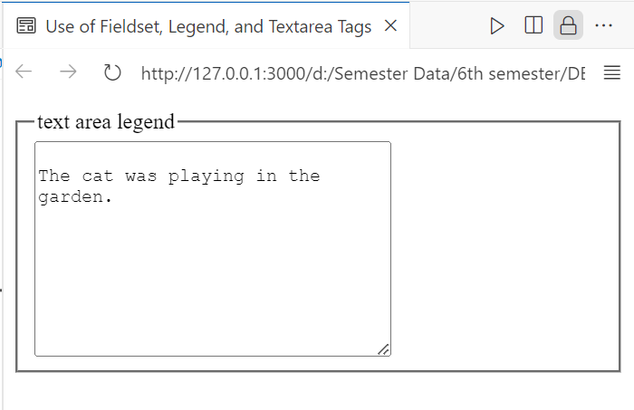**

**Conclusion:**

This HTML page demonstrates the **use of <fieldset>, <legend>, and <textarea>**:

1. **<fieldset>** – Groups related form elements together.
2. **<legend>** – Provides a title for the fieldset (**"text area legend"**).
3. **<textarea>** – Creates a multi-line text input box (**10 rows & 30 columns**).

**Example 17:**<html>

<head>

<title> Use of Form Attributes </title>

</head>

<body>

<form name="input" action="html_form_submit.asp" method="get">

Username:

<input type="text" name="user" />

<input type="submit" value="Submit" />

 </form>

 </body>

 </html>

**Output:**

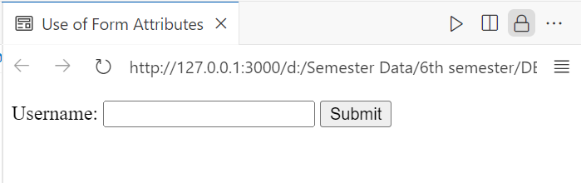

### Conclusion: This HTML form demonstrates the use of **form attributes**:

1. **name="input"** – Assigns a name to the form.
2. **action="html_form_submit.asp"** – Specifies where to send form data after submission.
3. **method="get"** – Sends form data as URL parameters (less secure but useful for simple queries).
4. **<input type="text" name="user" />** – Creates a text input for the username.
5. **<input type="submit" value="Submit" />** – Adds a submit button to send data.

**TASK 2.2:**

**Homework 1:** Forms play critical role in taking data to and from users. To enhance this ability, design three different types of forms using HTML Form. (Note: Don’t use CSS or Bootstrap. Only HTML.) Example forms can be registration form, contact form, student feedback form, etc. Provide short description and code of each form with its respective output in your lab report.

**Form 1:**

**Code:**

<!DOCTYPE html>

<html>

<head>

    <title>Registration Form</title>

</head>

<body align="center">

    <h2>Registration Form</h2>

    <form action="#" method="post">

        <label for="name">Full Name:</label>

        <input type="text" id="name" name="name" required><br><br><br>

        <label for="email">Email:</label>&nbsp;&nbsp;&nbsp;&nbsp;&nbsp;&nbsp;

        <input type="email" id="email" name="email" required><br><br><br>

        <label for="password">Password:</label>&nbsp;&nbsp;

        <input type="password" id="password" name="password" required><br><br><br>

        <label>Gender:</label>

        <input type="radio" id="male" name="gender" value="male">

        <label for="male">Male</label>

        <input type="radio" id="female" name="gender" value="female">

        <label for="female">Female</label><br><br>

        <input type="submit" value="Register">

    </form>

</body>

</html>

**OUTPUT:**

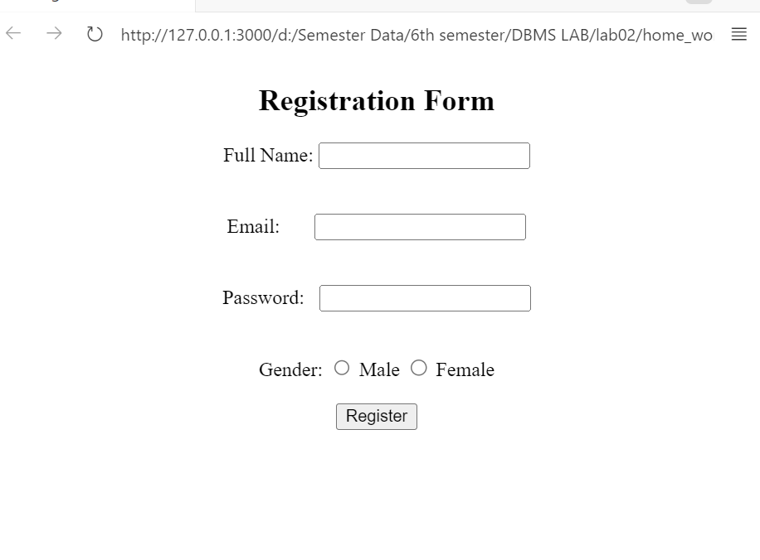

**Description:**

This registration form is well-organized and centered on the page. It collects the user's full name, email, password, and gender, with proper labels linked to each input. Radio buttons are used for gender selection, allowing only one choice. The form includes validation using the required attribute to ensure all fields are filled before submission.

**Form 2:**

**Code:**

<!DOCTYPE html>

<html>

<head>

    <title>Contact Form</title>

</head>

<body align="center">

    <h2>Contact Us</h2>

    <form action="#" method="post">

        <label for="name">Name:</label>

        <input type="text" id="name" name="name" required><br><br>

        <label for="email">Email:</label>

        <input type="email" id="email" name="email" required><br><br>

        <label for="subject">Subject:</label>

        <input type="text" id="subject" name="subject" required><br><br>

        <label for="message">Message:</label><br>

        <textarea id="message" name="message" rows="4" cols="50" required></textarea><br><br>

        <input type="submit" value="Send Message">

    </form>

</body>

</html>

**Output:**

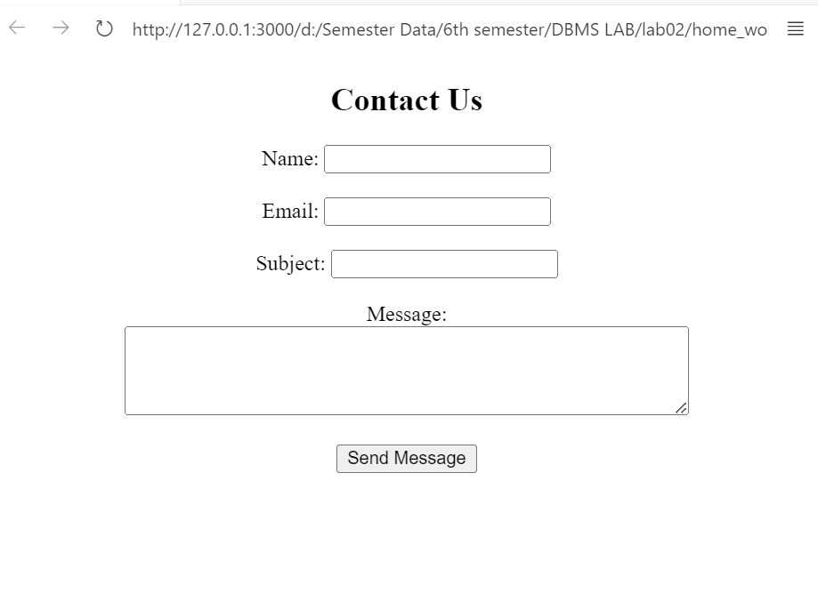

**Description:**

This contact form is centered on the page and collects the user's name, email, subject, and message. It uses text inputs for basic details and a larger text area for the message. Labels are correctly linked to each input, ensuring accessibility. All fields are required, preventing empty submissions.

**Form 3:**

**Code:**

<!DOCTYPE html>

<html>

<head>

    <title>Student Feedback Form</title>

</head>

<body align="center">

    <h2>Student Feedback Form</h2>

    <form action="#" method="post">

        <label for="name">Name:</label>

        <input type="text" id="name" name="name" required><br><br>

        <label for="course">Course Name:</label>

        <input type="text" id="course" name="course" required><br><br>

        <label for="rating">Rate the Course:</label>

        <select id="rating" name="rating">

            <option value="excellent">Excellent</option>

            <option value="good">Good</option>

            <option value="average">Average</option>

            <option value="poor">Poor</option>

        </select><br><br>

        <label for="comments">Comments/Suggestions:</label><br>

        <textarea id="comments" name="comments" rows="4" cols="50"></textarea><br><br>

        <input type="submit" value="Submit Feedback">

    </form>

</body>

</html>

**Output:**

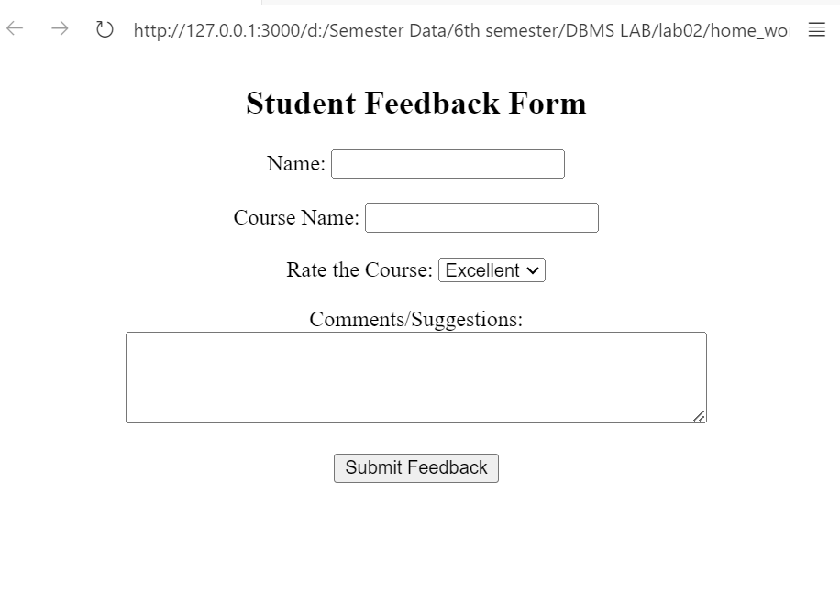

**Description:**

This student feedback form collects the user's name, course name, rating, and comments. It uses a dropdown menu for the course rating and a textarea for additional feedback. Labels are linked to inputs for better accessibility. Required fields ensure essential information is provided before submission.

**TASK 2.3:**

**Homework 2:** There are many new features available in HTML 5. Pick at least five features that are not covered in this lab and introduce its usage through detailed examples and description. These features include figure, audio, video, svg, regular expressions, GeoLocation, canvas, article, section, header, footer, drag & drop, form validation, and web sockets. Provide short description and code of each feature with its respective output in your lab report.

**Feature 1:**

**image**

code:

<!DOCTYPE html>

<html>

<head>

    <title>Figure Example</title>

</head>

<body>

    <figure>

        <img src="download.jpeg" alt="Beautiful Landscape" width="400">

        <figcaption>A beautiful landscape at sunset.</figcaption>

    </figure>

</body>

</html>

**Output:**

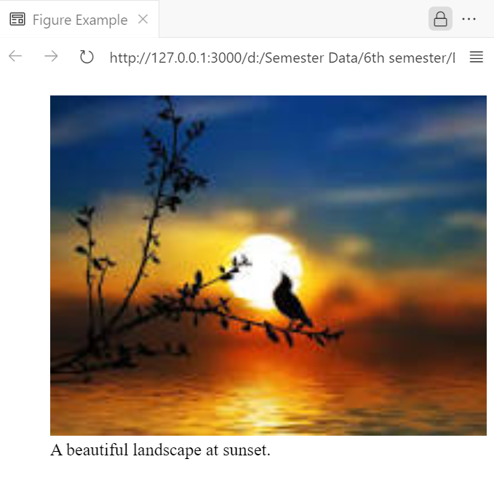

**Description:**

This example uses the <figure> and <figcaption> tags to display an image with a caption below it. It groups the image and its description together. This improves the semantic structure and accessibility of the content.

**Feature 2:**

**audio**

**Code:**

<!DOCTYPE html>

<html>

<head>

    <title>Audio Example</title>

</head>

<body>

    <audio controls>

        <source src="audio.mp3" type="audio/mp3">

        Your browser does not support the audio element.

    </audio>

</body>

</html>

**Output;**

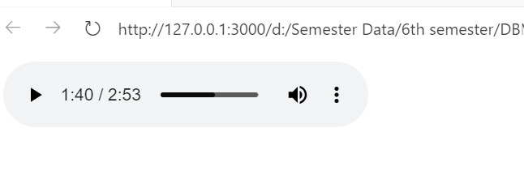

**Description:**

This example uses the <audio> tag to embed an audio file with controls for play, pause, and volume. It supports multiple audio formats. This allows users to listen to audio directly on the webpage.

**Feature 3:**

**Video**

**Code:**

<!DOCTYPE html>

<html>

<head>

    <title>Video Example</title>

</head>

<body>

    <video width="500" controls>

        <source src="video.mp4" type="video/mp4">

        Your browser does not support the video tag.

    </video>

</body>

</html>

**Output:**

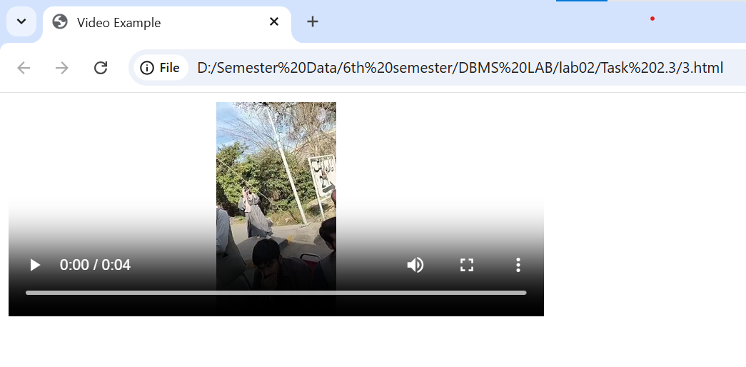

**Description:**

This feature uses the <video> tag to embed a video with a width of 500 and height of 200. It includes built-in controls for play, pause, volume, and full screen. This allows users to watch videos directly on the webpage.

**Feature 4:**

**Section**

**code**

<!DOCTYPE html>

<html>

<head>

    <title>Section Example</title>

</head>

<body>

    <section>

        <h2>About Us</h2>

        <p>We provide quality products worldwide.</p>

    </section>

    <section>

        <h2>Contact Us</h2>

        <p>Email: info@example.com</p>

    </section>

</body>

</html>

**Output;**

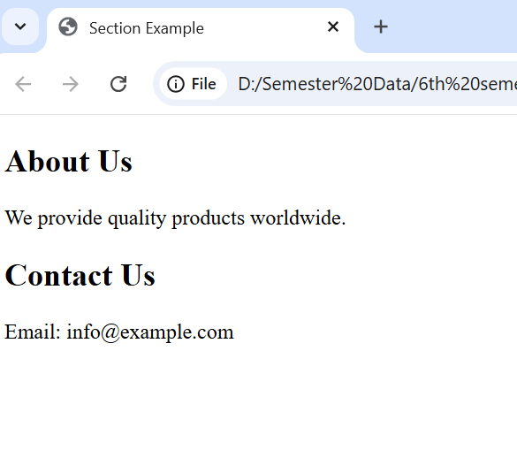

**Description:**

This feature uses the <section> tag to organize content into clear sections with headings. It separates the "About Us" and "Contact Us" information for better structure. This improves readability and semantic meaning on the webpage.

**Feature 5:**

**Article**

**Code:**

<!DOCTYPE html>

<html>

<head>

    <title>Article Example</title>

</head>

<body>

    <article>

        <h2>Breaking News: Technology Advancements</h2>

        <p>New technology trends are shaping the future of innovation...</p>

        <p>Read more to stay updated with the latest advancements in tech.</p>

        <footer>Published on: February 27, 2025</footer>

    </article>

</body>

</html>

**Output:**

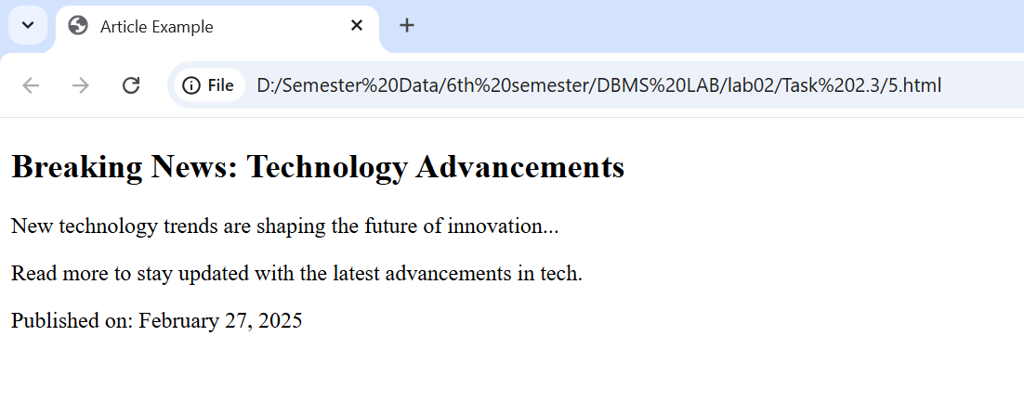

**Description:**This example uses the <article> tag to display a news post with a heading, content, and a footer for the publish date. It represents an independent, self-contained piece of information. This is ideal for blog posts or news articles.

**Task 2.4:**

**Homework 3:** Design your CV using HTML 5 only and host it on 000webhost.com. (Note: You can host it on any other free hosting site of your choice.)

**Code:**

<!DOCTYPE html>

<html>

<head>

    <title>Mohsin Sajjad - CV</title>

</head>

<body>

    <table width="100%">

        <tr>

            <td width="35%" valign="top">

                <h2>Mohsin Sajjad</h2>

                <p>Student</p>

                <h3>Contact</h3>

                <ul>

                    <li>📞 +923125432079</li>

                    <li>✉️ 22pwcse2149@uetpeshawar.edu.pk</li>

                    <li>📍 Village Granthali, District Mansehra</li>

                </ul>

                <h3>About Me</h3>

                <p>Quick learner with strong programming, embedded systems, and networking skills. Passionate about problem-solving and continuous learning. Awarded a laptop under the PM Laptop Scheme for high GPA. Committed to innovation and efficiency.</p>

                <h3>Skills</h3>

                <ul>

                    <li>Programming: C/C++, Python</li>

                    <li>Networking: OSI, TCP/IP, Protocols</li>

                    <li>Operating System: Linux</li>

                    <li>Software Development: DSA</li>

                    <li>Communication and Team work</li>

                    <li>Problem Solving and Critical Thinking</li>

                </ul>

            </td>

            <td width="65%" valign="top">

                <h3>Education</h3>

                <ul>

                    <li><strong>BSc: Computer System Engineering</strong><br>University of Engineering And Technology Peshawar (2022 - 2026)</li>

                    <li><strong>Intermediate: Pre-Engineering (CS)</strong><br>Borcelle University (2020 - 2022)</li>

                    <li><strong>Matriculation: Science</strong><br>Govt. High School Dadar (2018 - 2020)</li>

                </ul>

                <h3>Work Experience</h3>

                <ul>

                    <li><strong>Clap Switch (Sensor-Based Circuit)</strong><br>Semester Project - Designed using a microphone sensor and amplifiers to control devices with a clap sound.</li>

                    <li><strong>Racing Monkey (ESP32-Based Robotics Project)</strong><br>Semester Project - Remote-controlled racing robot using ESP32, motors, and sensors.</li>

                    <li><strong>Job Scheduler (Shell-Based)</strong><br>Semester Project - Reads user commands and runs tasks sequentially.</li>

                    <li><strong>Space Mission Control System Simulation</strong><br>Semester Project - C simulation enabling communication between mission control and Earth.</li>

                    <li><strong>Brick Breaker Game</strong><br>Semester Project - Developed using C and a graphics library (SFML).</li>

                </ul>

                <h3>Certificates and Achievements</h3>

                <ul>

                    <li>Awarded a laptop for high GPA (PM Laptop Scheme)</li>

                    <li>Get Started with Python – Coursera</li>

                    <li>Technical Support Fundamentals – Coursera</li>

                    <li>Bits and Bytes of Networking – Coursera</li>

                    <li>Operating Systems – Coursera</li>

                </ul>

            </td>

        </tr>

    </table>

</body>

</html>

**Output:**

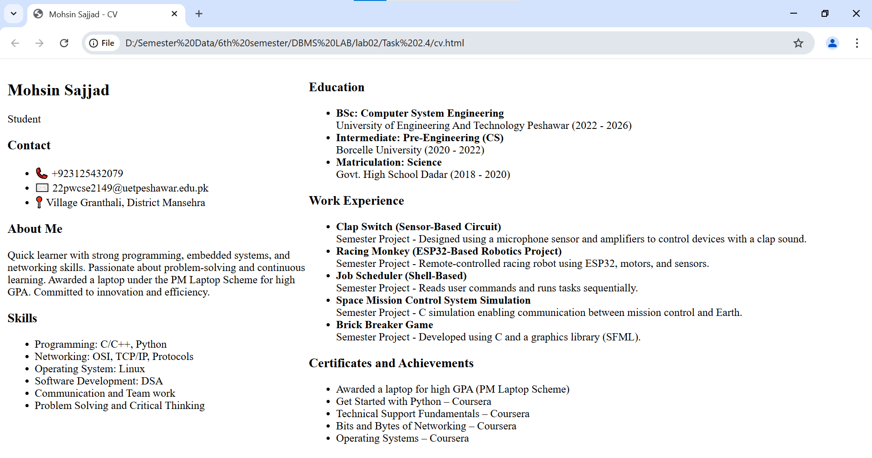

**Description:**

This HTML document is structured using a **table** to organize content into two main sections: the **left panel** (personal details, skills) and the **right panel** (education, work experience, certifications). The <html> tag defines the document, while <head> contains the <title> for the webpage. The <body> tag holds all visible content.

A <table> with width="100%" ensures it spans the full page. The <tr> (table row) and <td> (table data) tags divide it into two columns, with width="35%" for the left and width="65%" for the right. The valign="top" aligns content to the top of each section.

Headings (<h2>, <h3>, <h4>) structure the sections, while <ul> (unordered lists) and <li> (list items) are used for skills, education, and experiences. <p> (paragraphs) provide descriptions. The strong tag bolds key points.

This layout ensures a **clean, readable**, and well-structured HTML-based CV.

**Link:**  
<https://bejewelled-cat-352cfd.netlify.app/>